Aoraki Mount Cook Marathon weekend – Accommodation and Adventure Activities

ACCOMODATION:

The Hermitage Hotel – Aoraki Mount Cook Village
From an intrepid journey through glacial valleys to a mouth-watering culinary dining adventure. The Hermitage Hotel is the perfect place to base your adventure and discover why this region has endeared itself to Kiwi adventure seekers for so long. Choose from premium hotel rooms, self-contained motel units or cozy chalets. www.hermitage.co.nz
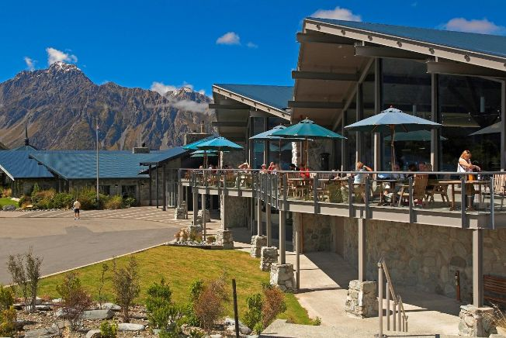

Mt Cook Lodge & Motels:
Mt Cook Lodge & Motels offers a great range of accommodation options for today's backpackers and budget conscious travelers. All rooms including en-suite bathrooms, quality linen, refrigerators and a patio or balcony so you can soak up the stunning mountain views. www.mtcookbackpackerlodge.co.nz
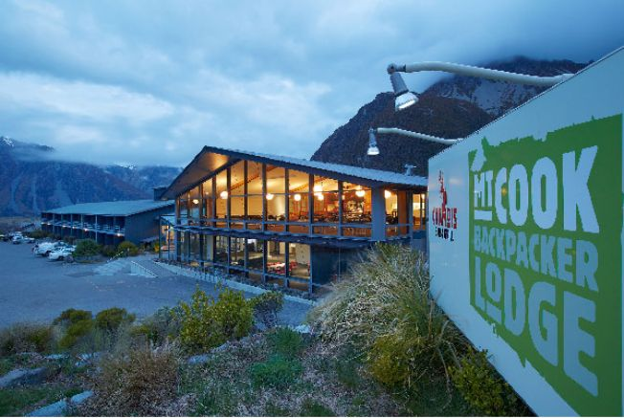

Glentanner Park:
Glentanner Park offers a range of Mt Cook accommodation and is the only fully equipped campground and Campervan Park for the Mount Cook region New Zealand, as well as the activity centre for flight-seeing and other Mt Cook activities. Located just 18km from Mt Cook National Park. Check out the promo video: www.youtube.com/watch?v=4IK65xa5Jm4#t=11
Self-Contained Units: Comfortable Motel Style units with amazing views of Aoraki Mount Cook. Sleep 1-5 people. Queen bed, 1 single and a double fold out couch. Own kitchen and bathroom. Wifi. www.glentanner.co.nz/accommodation/self-contained-cabins
Basic Units: A private room for those on a budget. The best views of Aoraki Mount Cook. Sleep 1-4. Queen bed and 2 singles. Linen is provided. Shared bathroom and kitchen in the main facilities block. Wifi. www.glentanner.co.nz/accommodation/basic-cabins
Large Standard Unit: Family friendly accommodation with 5 single bunk beds (sleeps 1-10). Includes toilet and hand basin. Other bathroom facilities and kitchen in the main facilities block. Wifi. www.glentanner.co.nz/accommodation/large-standard-cabins
Smaller Standard Unit: Great for those on a budget! Contains a duo bunk and 2 single bunks sleeping up to 7. Bathroom and kitchen facilities in the main facilities block. Wifi. www.glentanner.co.nz/accommodation/smaller-cabins
Dormitory/Backpackers: 1 bed in our 10 bed dormitory (5 single bunk beds). Room contains a toilet and hand basin, kitchen and other bathroom facilities in the main facilities block. Wifi.. Not suitable for families. www.glentanner.co.nz/accommodation/backpackers
Powered Campervan Sites: Choose your own from 60 sheltered, spacious and level sites. Great views of Aoraki Mt Cook and Lake Pukaki. Wifi. Includes full facilities such as bathroom (hot showers!), kitchen, lounge TV room, laundry and BBQ Pavilion. www.glentanner.co.nz/accommodation/power-sites
Non Powered Tent Sites: Choose your own from an unlimited number of spacious sites! Panoramic views of Aoraki Mt Cook and Lake Pukaki. Wifi. Includes full faciltiies such as bathroom (hot showers!), kitchen, lounge TV room, laundry and BBQ Pavilion. www.glentanner.co.nz/accommodation/tent-sites
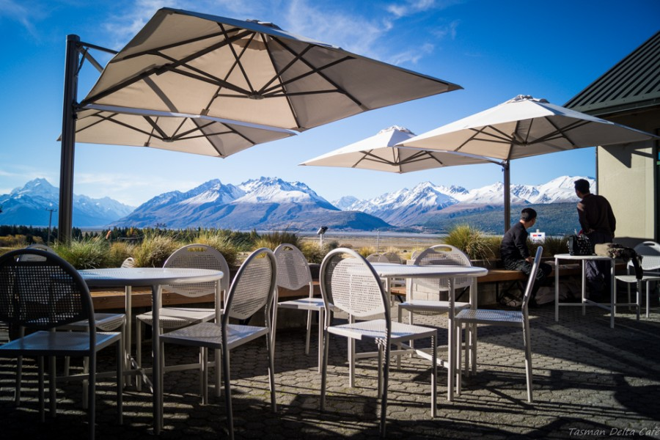

ADVENTURE ACTIVITIES:

Glacier Explorers:
The only tour of its kind in New Zealand. An amazing encounter with New Zealand's largest glacier, the Tasman Glacier. Explore, learn and discover the ever-changing glacial landscape as you journey across the Tasman Glacier Terminal Lake in a custom-built MAC Boat with your experienced guide. www.glacierexplorers.com
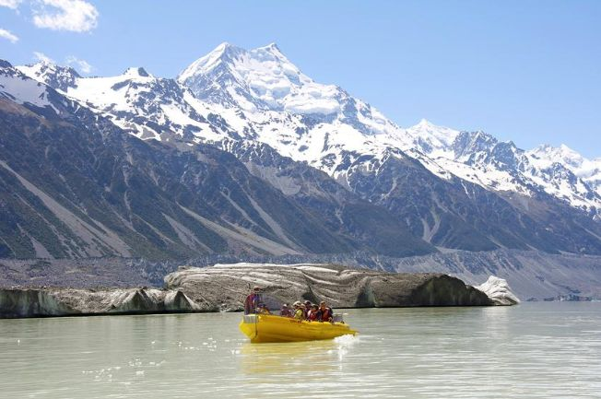

Tasman Valley 4WD & Argo Tours:
A unique 4WD & Argo adventure with incredible views of the Tasman Glacier, its terminal lake and gigantic moraine walls. Learn about the area and take a short walk to a vantage point overlooking the Tasman Glacier providing one of the most spectacular photographic opportunities in the Aoraki Mount Cook National Park www.mountcooktours.co.nz.
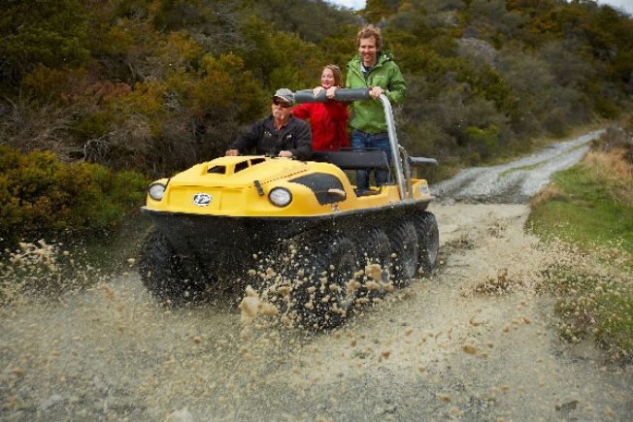

Big Sky Stargazing:
Mount Cook is far from the city lights and therefore has some of the darkest skies in New Zealand. Begin with an introduction in our Theatre Planetarium before our informative astronomy guides take you to our outdoor stargazing site. Use state-of-the-art telescopes, high powered binoculars and the naked eye, put your newly acquired knowledge into practice, identifying and exploring different elements of the spectacular southern sky. www.bigskystargazing.co.nz
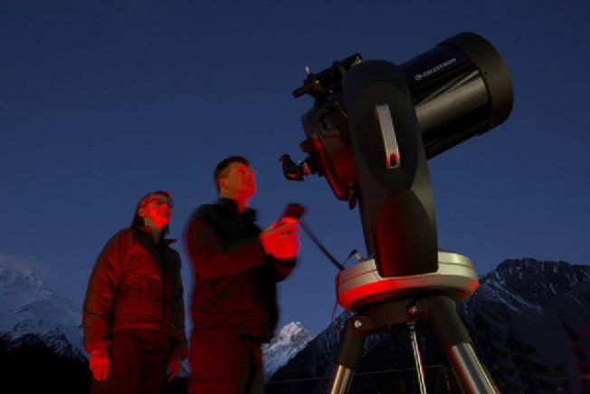

Sir Edmund Hillary Alpine Centre:
A tribute to Sir Edmund Hillary the centre showcases the Aoraki Mount Cook region, its people and its place in the universe. The theatre is the only in the world with 2D, 3D and Digital Dome Planetarium, contained within the same space. The museum showcases the history of the Mount Cook region through transport, climbing, The Hermitage Hotel and pioneer extraordinaire, Sir Edmund Hillary himself. www.hillarycentre.co.nz
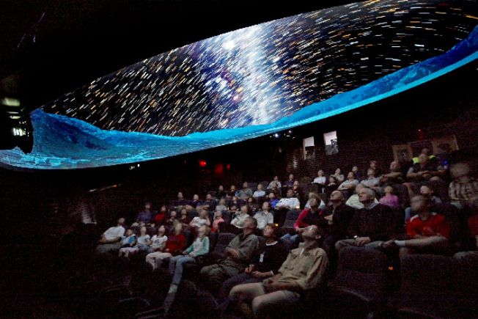

Mount Cook Ski Planes:
Mount Cook Ski Planes - join us on a spectacular Ski Plane or Helicopter flight in Aoraki / Mt Cook and Westland National Parks, South Island, New Zealand... You'll be amazed!
Experience a touch of adventure with Mount Cook Ski Planes. No zoom lens required, your flight with us begins in Aoraki/Mount Cook National Park, flying past our highest peak Aoraki/Mount Cook and landing you on the Tasman Glacier. You will then fly across the Main Divide of the Southern Alps to view the sweeping coastline and stunning alpine vistas of the Fox and Franz Josef Glaciers. You choose how you would like to experience this spectacular scenery with us from our fleet of aircraft including; PC6 Pilatus Porter Ski Planes and Cessna 185 Ski Planes.
Mount Cook Ski Planes are the only company offering scenic flights with both fixed wing Ski Planes from Aoraki Mount Cook Airport, right in the heart of Aoraki/Mount Cook National Park (a World Heritage Area), only a few kilometres from Mount Cook Village and The Hermitage Hotel.
It is our great privilege to be the only company approved to land on the mighty Tasman Glacier, the longest glacier in New Zealand. Our highly experienced mountain pilots are waiting to share with you their wealth of knowledge of this truly unique alpine environment. www.mtcookskiplanes.com
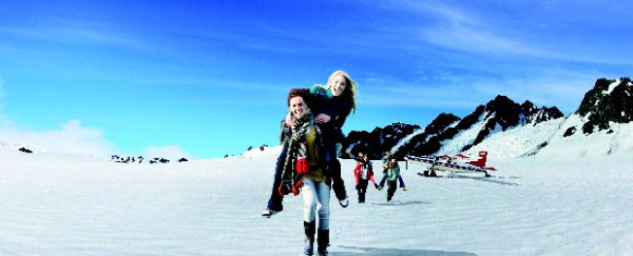

Glentanner Horse Trekking:
Guided Horse Treks on Glentanner Station. Panoramic views of Aoraki Mount Cook and surrounding Alps, and Lake Pukaki. Suitable for beginners to experienced riders. 1/2hr, 1hr, 2hr and 3hr treks. Riders must be 100kg or less, and over the age of 10. www.glentanner.co.nz/mt-cook-activities/horse-treks-mt-cook
